CYCLE A (2029/30)
Autumn 1 | Autumn 2 | Spring 1 | Spring 2 | Summer 1 | Summer 2
Scots and Anglo-Saxons | Majestic Mountains | Raiders and Invaders | The UK  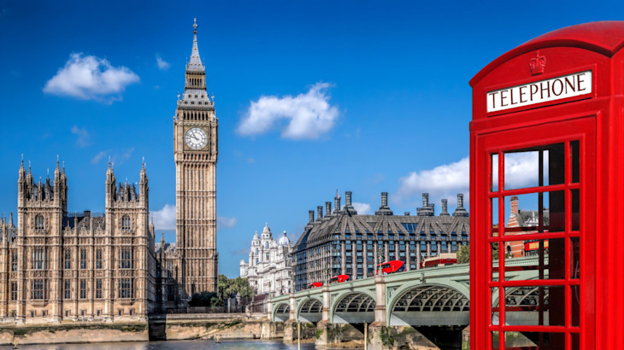 | Incredible Oxford | Incredible Oxford
CYCLE B (2026/27)
Autumn 1 | Autumn 2 | Spring 1 | Spring 2 | Summer 1 | Summer 2
Ruthless Romans | Natural disasters | The Tudors | Water, water everywhere | WW2 | American Adventures

CYCLE C (2027/28)
Autumn 1 | Autumn 2 | Spring 1 | Spring 2 | Summer 1 | Summer 2
Ancient Greece | Athens, Greece | Mayan Civilisation | Rainforests | The Victorians | Marvellous maps

CYCLE D (2028/29)
Autumn 1 | Autumn 2 | Spring 1 | Spring 2 | Summer 1 | Summer 2
Building Britain | Extreme Earth | Freeland and beyond | Freeland and beyond | Ancient Egypt | Amazing Africa

Cycle A

Scots and Anglo-Saxons (A1)
Red Kites | Kingfishers | Golden Eagles
Key Concepts
Children develop an understanding of how Britain changed after the Romans left and how the Anglo-Saxons and Scots shaped Britain's history. They learn who the Anglo-Saxons and Scots were, why they settled in Britain, how they lived, and how their culture, beliefs, language and kingdoms influenced life today. Pupils develop chronological understanding, historical enquiry skills and an appreciation of how historians use evidence to interpret the past. | Children investigate how Anglo-Saxon and Scottish kingdoms developed, how people lived, and how Britain changed during this period. They examine causes and consequences of migration and settlement. | Children analyse the impact of the Anglo-Saxons and Scots on Britain, evaluating their legacy and significance in shaping modern Britain. They use historical evidence to form and justify interpretations.
Key Knowledge
• I know that the Romans left Britain around AD 410.  • I know that the Anglo-Saxons came from areas of northern Europe.  • I know that people in Anglo-Saxon Britain lived in villages and worked as farmers, craftsmen and traders.  • I know that the Scots came from Ireland and settled in parts of Scotland.  • I know that Anglo-Saxons settled in different parts of Britain and established kingdoms.  • I know that Britain changed after the Romans left. | • I know that there were seven major Anglo-Saxon kingdoms (the Heptarchy).  • I know that Anglo-Saxon settlements influenced place names still used today.  • I know that Anglo-Saxon people had their own laws, beliefs and traditions.  • I know that Christianity spread through Anglo-Saxon Britain.  • I know that migration and settlement changed Britain's culture and society. | • I know that Anglo-Saxon and Scottish cultures helped shape modern Britain.  • I know that historical sources provide different perspectives about the period.  • I know that the conversion to Christianity had a significant impact on society.  • I know that Anglo-Saxon governance influenced later systems of law and leadership.  • I know that historians use evidence to understand and interpret the past.
Key Skills
• I can place Anglo-Saxon and Scottish settlements on a timeline.  • I can identify where the Anglo-Saxons and Scots came from.  • I can compare life in Anglo-Saxon Britain with life today.  • I can describe key features of Anglo-Saxon life.  • I can describe how people lived during the Anglo-Saxon period.  • I can ask and answer questions about the past.  • I can use historical vocabulary appropriately. | • I can explain why people migrated and settled in Britain.  • I can compare aspects of Anglo-Saxon and Scottish life.  • I can use historical sources to find information.  • I can identify causes and consequences of historical events.  • I can describe changes over time. | • I can evaluate the significance of Anglo-Saxon and Scottish contributions to Britain.  • I can analyse and interpret different historical sources.  • I can explain how evidence supports historical conclusions.  • I can discuss continuity and change across time periods.  • I can present reasoned historical arguments using evidence.
Red Kites | Kingfishers | Golden Eagles
Topic Outcomes
Who were the Anglo-Saxons and Scots, and why did they come to Britain? | How did Anglo-Saxon and Scottish settlements change Britain? | How significant were the Anglo-Saxons and Scots in shaping Britain today?
Core Books
Title - Author | Title - Author | Title - Author
Vocabulary Progression
Roman, Anglo-Saxon, Scot, settlement, migration, invader, kingdom, village, tribe, Britain, chronology | Heptarchy, kingdom, monarch, conversion, Christianity, monastery, missionary, culture, settlement, artefact, evidence | significance, interpretation, legacy, source, reliability, continuity, change, governance, law, influence, perspective

Statutory curriculum links
Year 2 | Year 3 | Year 4 | Year 5 | Year 6
Pupils should be taught about events beyond living memory that are significant nationally or globally.  Pupils should be taught about significant historical events, people and places in their own locality | Pupils should be taught about Britain’s settlement by Anglo-Saxons and Scots. (eg. Roman withdrawal from Britain in c. AD 410 and the fall of the western Roman Empire; Scots invasions from Ireland to north Britain (now Scotland); Anglo-Saxon invasions, settlements and kingdoms: place names and village life; Anglo-Saxon art and culture; Christian conversion: Canterbury and Lindisfarne). | Pupils should be taught about Britain’s settlement by Anglo-Saxons and Scots. (eg. Roman withdrawal from Britain in c. AD 410 and the fall of the western Roman Empire; Scots invasions from Ireland to north Britain (now Scotland); Anglo-Saxon invasions, settlements and kingdoms: place names and village life; Anglo-Saxon art and culture; Christian conversion: Canterbury and Lindisfarne). | Pupils should be taught about Britain’s settlement by Anglo-Saxons and Scots. (eg. Roman withdrawal from Britain in c. AD 410 and the fall of the western Roman Empire; Scots invasions from Ireland to north Britain (now Scotland); Anglo-Saxon invasions, settlements and kingdoms: place names and village life; Anglo-Saxon art and culture; Christian conversion: Canterbury and Lindisfarne). | Pupils should be taught about Britain’s settlement by Anglo-Saxons and Scots. (eg. Roman withdrawal from Britain in c. AD 410 and the fall of the western Roman Empire; Scots invasions from Ireland to north Britain (now Scotland); Anglo-Saxon invasions, settlements and kingdoms: place names and village life; Anglo-Saxon art and culture; Christian conversion: Canterbury and Lindisfarne).

Majestic Mountains (A2)

Red Kites | Kingfishers | Golden Eagles
Key Concepts
Key Knowledge
Key Skills
Red Kites | Kingfishers | Golden Eagles
Topic Outcomes
Core Books
Vocabulary Progression

Statutory curriculum links
Year 3 | Year 4 | Year 5 | Year 6

Raiders and Invaders (A3)

Red Kites | Kingfishers | Golden Eagles
Key Concepts
Key Knowledge
Key Skills
Red Kites | Kingfishers | Golden Eagles
Topic Outcomes
Core Books
Vocabulary progression

Statutory curriculum links
Year 3 | Year 4 | Year 5 | Year 6

The UK (A4)

Red Kites | Kingfishers | Golden Eagles
Key Concepts
Key Knowledge
Key Skills
Red Kites | Kingfishers | Golden Eagles
Topic Outcomes
Core Books
Vocabulary progression

Statutory curriculum links
Year 3 | Year 4 | Year 5 | Year 6

Incredible Oxford (A5)
Red Kites | Kingfishers | Golden Eagles
Key Concepts
Key Knowledge
Key Skills
Red Kites | Kingfishers | Golden Eagles
Topic Outcome
Statutory Curriculum Links
Core Books
Vocabulary progression

Statutory curriculum links
Year 3 | Year 4 | Year 5 | Year 6

Incredible Oxford (A6)
Red Kites | Kingfishers | Golden Eagles
Key Concepts
Key Knowledge
Key Skills
Reception | Year One | Year Two
Core Books
Vocabulary progression

Statutory curriculum links
Year 3 | Year 4 | Year 5 | Year 6

Cycle B

Ruthless Romans (B1)
Red Kites |  | Kingfishers | Golden Eagles
Key Concepts
Discovering the Romans – Children are introduced to who the Romans were, where they came from and why they invaded Britain. They explore Roman soldiers, daily life, homes, roads and the lasting impact of Roman rule on Britain |  | Life in Roman Britain – Children develop a deeper understanding of the Roman Empire, the conquest of Britain, Boudicca's rebellion, Roman settlements, engineering, religion and the spread of Roman culture. They compare Roman life with Iron Age Britain and investigate Roman achievements. | The Legacy of Rome – Children critically examine the rise and fall of the Roman Empire, the impact of Roman rule across Europe, Britain and beyond, and evaluate how Roman innovations continue to influence modern society. They use a range of historical sources to form balanced historical interpretations.
Key Knowledge
• I know the Romans came from Rome in Italy.  • I know the Romans invaded Britain nearly 2,000 years ago.  • I know Roman soldiers travelled in organised armies.  • I know Romans built straight roads, forts and towns.  • I know some people in Britain fought against the Romans, including Boudicca.  • I know many Roman ideas still influence Britain today. |  | • I know the Roman Empire spread across Europe, North Africa and parts of Asia.  • I know Emperor Claudius successfully invaded Britain in AD 43.  • I know Boudicca led a rebellion against Roman rule.  • I know Roman towns had baths, forums, amphitheatres and villas.  • I know Roman engineering improved transport, sanitation and buildings.  • I know Christianity spread through the Roman Empire.  • I know Roman rule changed life in Britain. | • I know historians use different sources to investigate Roman history.  • I know the Roman Empire expanded through military strength and organisation.  • I know there were different reasons for the success and decline of the Roman Empire.  • I know Roman law, language, engineering and government influenced later civilisations.  • I know historical evidence can lead to different interpretations.  • I know Roman Britain was part of a much larger empire with global connections.
Key Skills
• I can place the Romans on a simple timeline.  • I can identify where Rome and Britain are on a map.  • I can compare Roman life with life today.  • I can ask and answer questions about the past.  • I can use pictures and artefacts to learn about Roman life.  • I can describe why the Romans are remembered. |  | • I can explain why the Romans invaded Britain.  • I can sequence key Roman events chronologically.  • I can compare Roman Britain with Iron Age Britain.  • I can investigate different historical sources.  • I can explain causes and consequences of Boudicca's rebellion.  • I can identify Roman influences still seen today.  • I can present findings using historical vocabulary. | • I can evaluate the reliability of different historical sources.  • I can explain different interpretations of Roman history.  • I can analyse causes and consequences of significant events.  • I can compare Roman civilisation with other ancient civilisations.  • I can justify opinions using historical evidence.  • I can communicate historical understanding through discussion and extended writing.  • I can make links between Roman achievements and modern society.
Red Kites |  | Kingfishers | Golden Eagles
Class Book
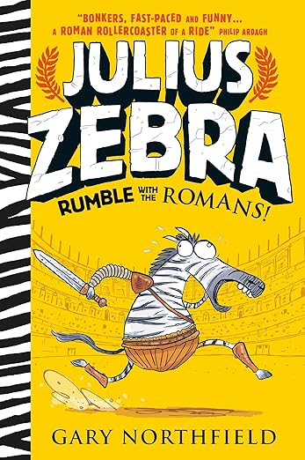  Year ⅔  Julius Zebra Rumble with the Romans - Gary Northfield | Year ¾  Julius Zebra Rumble with the Romans - Gary Northfield | Year ⅘  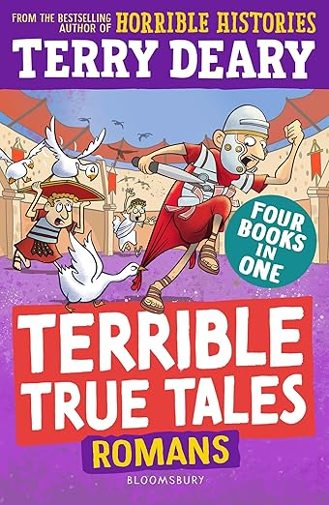  Terrible True Tales: Romans - Terry Deary | Year ⅚  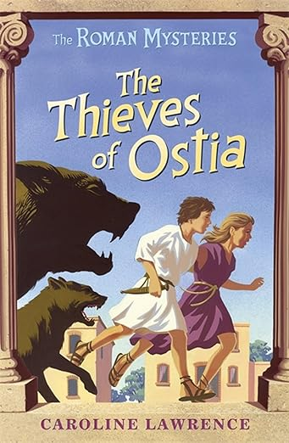  The Roman Mysteries: The Thieves of Ostia - Caroline Lawrence
Hook lesson
Carousel activity with all of KS2. The children will discover different artefacts to uncover who the Romans were and use this to infer what Roman life was like.

Vocabulary Progression
Roman, Rome, Italy, Empire, Emperor, soldier, legion, centurion, invasion, Britain, Boudicca, fort, road, villa, town, mosaic, shield, helmet, chariot |  | Empire, republic, emperor, legion, legionary, centurion, conquest, invasion, Claudius, Boudicca, Iceni, revolt, villa, bathhouse, aqueduct, forum, amphitheatre, gladiator, mosaic, archaeology, artefact, province, Hadrian's Wall, Latin, Christianity | civilisation, governance, republic, democracy, empire, expansion, conquest, economy, trade, taxation, engineering, infrastructure, interpretation, evidence, primary source, secondary source, chronology, legacy, influence, citizenship, architecture, aqueduct, sanitation, decline, historian

 | Statutory curriculum links
Year 2 | Year 3 | Year 4 | Year 5 | Year 6
Pupils should be taught about events beyond living memory that are significant nationally or globally.  Pupils should be taught about significant historical events, people and places in their own locality. | Pupils should be taught about the Roman Empire and its impact on Britain.  This could include: Julius Caesar’s attempted invasion in 55-54 BC; the Roman Empire by AD 42 and the power of its army; successful invasion by Claudius and conquest, including Hadrian’s Wall British resistance, for example, Boudica ‘Romanisation’ of Britain; sites such as Caerwent and the impact of technology, culture and beliefs, including early Christianity. | Pupils should be taught about the Roman Empire and its impact on Britain.  This could include: Julius Caesar’s attempted invasion in 55-54 BC; the Roman Empire by AD 42 and the power of its army; successful invasion by Claudius and conquest, including Hadrian’s Wall British resistance, for example, Boudica ‘Romanisation’ of Britain; sites such as Caerwent and the impact of technology, culture and beliefs, including early Christianity. | Pupils should be taught about the Roman Empire and its impact on Britain.  This could include: Julius Caesar’s attempted invasion in 55-54 BC; the Roman Empire by AD 42 and the power of its army; successful invasion by Claudius and conquest, including Hadrian’s Wall British resistance, for example, Boudica ‘Romanisation’ of Britain; sites such as Caerwent and the impact of technology, culture and beliefs, including early Christianity. | Pupils should be taught about the Roman Empire and its impact on Britain.  This could include: Julius Caesar’s attempted invasion in 55-54 BC; the Roman Empire by AD 42 and the power of its army; successful invasion by Claudius and conquest, including Hadrian’s Wall British resistance, for example, Boudica ‘Romanisation’ of Britain; sites such as Caerwent and the impact of technology, culture and beliefs, including early Christianity.

Natural disasters (B2)

Red Kites |  | Kingfishers | Golden Eagles
Key Concepts
Understanding Natural Disasters – Children are introduced to the different types of natural disasters, where they happen and how they affect people and places. They explore simple geographical processes and begin to understand how communities prepare for and respond to hazards. |  | Exploring Earth's Powerful Processes – Children investigate how natural disasters are caused by physical processes within the Earth and atmosphere. They study volcanoes, earthquakes, tsunamis, hurricanes and floods, comparing how different countries prepare for and respond to these events. | Global Impact and Resilience – Children develop a deeper understanding of the causes, consequences and management of natural disasters. They examine the relationship between human activity, climate change and increasing natural hazards, evaluating how governments and organisations reduce risk and support affected communities.
Key Knowledge
• I know a natural disaster is caused by nature.  • I know natural disasters can include floods, earthquakes, volcanoes, storms and wildfires.  • I know natural disasters can change landscapes and affect people's lives.  • I know some places experience certain natural disasters more often than others.  • I know people can prepare to stay safe during some natural disasters.  • I know emergency services help people after disasters. |  | • I know earthquakes are caused by movement of tectonic plates.  • I know volcanoes form where magma reaches the Earth's surface.  • I know tsunamis are often triggered by underwater earthquakes.  • I know tropical storms form over warm oceans.  • I know flooding can have natural and human causes.  • I know different countries prepare for disasters in different ways.  • I know natural disasters have social, economic and environmental impacts. | • I know tectonic plate boundaries influence earthquakes and volcanic activity.  • I know climate change may increase the frequency or intensity of some natural hazards, such as flooding and extreme weather.  • I know the impacts of natural disasters vary depending on a country's wealth, infrastructure and preparedness.  • I know organisations work together to reduce disaster risk and provide humanitarian aid.  • I know geographical evidence helps predict and monitor natural hazards.  • I know sustainable planning can reduce the effects of natural disasters.
Key Skills
• I can identify different natural disasters.  • I can locate places affected by natural disasters on a world map.  • I can describe how natural disasters affect people and places.  • I can compare different types of natural disasters.  • I can ask geographical questions and use photographs and maps to find answers.  • I can explain simple ways people stay safe. |  | • I can explain how earthquakes and volcanoes occur.  • I can interpret maps showing tectonic plate boundaries.  • I can compare the impacts of different natural disasters.  • I can investigate real-life case studies.  • I can use atlases, digital maps and geographical data.  • I can explain how preparation reduces risks.  • I can present geographical findings using appropriate vocabulary. | • I can analyse the causes and impacts of natural disasters using evidence.  • I can evaluate how successful different disaster responses have been.  • I can compare disasters in countries with different levels of development.  • I can interpret a range of geographical data, maps and satellite images.  • I can explain links between climate change and natural hazards.  • I can communicate balanced geographical arguments using evidence.  • I can suggest ways communities can become more resilient to natural disasters.
Red Kites |  | Kingfishers | Golden Eagles
Class Book
Year ⅔  Julius Zebra Rumble with the Romans - Gary Northfield | Year ¾  Julius Zebra Rumble with the Romans - Gary Northfield | Year ⅘  Terrible True Tales: Romans - Terry Deary | Year ⅚  The Roman Mysteries: The Thieves of Ostia - Caroline Lawrence
Hook lesson

Statutory curriculum links
Year 2 | Year 3 | Year 4 | Year 5 | Year 6

The Tudors (B3)

Red Kites | Kingfishers | Golden Eagles
Key Concepts
Key Knowledge
Key Skills
Red Kites | Kingfishers | Golden Eagles
Topic Outcomes
Core Books
Vocabulary progression

Statutory curriculum links
Year 3 | Year 4 | Year 5 | Year 6

Water, Water everywhere (B4)

Red Kites | Kingfishers | Golden Eagles
Key Concepts
Key Knowledge
Key Skills
Red Kites | Kingfishers | Golden Eagles
Topic Outcomes
Vocabulary progression

Statutory curriculum links
Year 3 | Year 4 | Year 5 | Year 6

WW2 (B5)
Red Kites | Kingfishers | Golden Eagles
Key Concepts
Key Knowledge
Key Skills
Red Kites | Kingfishers | Golden Eagles
Topic Outcome
Statutory Curriculum Links
Core Books
Vocabulary progression

Statutory curriculum links
Year 3 | Year 4 | Year 5 | Year 6

American Adventure (B6)
Red Kites | Kingfishers | Golden Eagles
Key Concepts
Key Knowledge
Key Skills
Vocabulary progression

Statutory curriculum links
Year 3 | Year 4 | Year 5 | Year 6

Cycle C

Ancient Greece (C1)
Red Kites | Kingfishers | Golden Eagles
Key Concepts
Key Knowledge
Key Skills
Red Kites | Kingfishers | Golden Eagles
Core Books
Vocabulary Progression

Statutory curriculum links
Year 3 | Year 4 | Year 5 | Year 6

Athens, Greece (C2)

Red Kites | Kingfishers | Golden Eagles
Key Concepts
Key Knowledge
Key Skills
Red Kites | Kingfishers | Golden Eagles
Topic Outcomes
Core Books
Vocabulary Progression

Statutory curriculum links
Year 3 | Year 4 | Year 5 | Year 6

Mayan Civilisation (C3)

Red Kites | Kingfishers | Golden Eagles
Key Concepts
Key Knowledge
Key Skills
Red Kites | Kingfishers | Golden Eagles
Topic Outcomes
Core Books
Vocabulary progression

Statutory curriculum links
Year 3 | Year 4 | Year 5 | Year 6

Rainforests (C4)

Red Kites | Kingfishers | Golden Eagles
Key Concepts
Key Knowledge
Key Skills
Red Kites | Kingfishers | Golden Eagles
Topic Outcomes
Core Books
Vocabulary progression

Statutory curriculum links
Year 3 | Year 4 | Year 5 | Year 6

The Victorians (C5)
Red Kites | Kingfishers | Golden Eagles
Key Concepts
Key Knowledge
Key Skills
Red Kites | Kingfishers | Golden Eagles
Topic Outcome
Statutory Curriculum Links
Core Books
Vocabulary progression

Statutory curriculum links
Year 3 | Year 4 | Year 5 | Year 6

Marvellous Maps (C6)
Red Kites | Kingfishers | Golden Eagles
Key Concepts
Key Knowledge
Key Skills
Reception | Year One | Year Two
Core Books
Vocabulary progression

Statutory curriculum links
Year 3 | Year 4 | Year 5 | Year 6

Cycle D

Building Britain (D1)
Red Kites | Kingfishers | Golden Eagles
Key Concepts
Key Knowledge
Key Skills
Red Kites | Kingfishers | Golden Eagles
Core Books
Vocabulary Progression

Statutory curriculum links
Year 3 | Year 4 | Year 5 | Year 6

Extreme Earth (D2)

Red Kites | Kingfishers | Golden Eagles
Key Concepts
Key Knowledge
Key Skills
Red Kites | Kingfishers | Golden Eagles
Topic Outcomes
Core Books
Vocabulary Progression

Statutory curriculum links
Year 3 | Year 4 | Year 5 | Year 6

Freeland and Beyond (D3)

Red Kites | Kingfishers | Golden Eagles
Key Concepts
Key Knowledge
Key Skills
Red Kites | Kingfishers | Golden Eagles
Topic Outcomes
Core Books
Vocabulary progression

Statutory curriculum links
Year 3 | Year 4 | Year 5 | Year 6

Freeland and Beyond (D4)

Red Kites | Kingfishers | Golden Eagles
Key Concepts
Key Knowledge
Key Skills
Red Kites | Kingfishers | Golden Eagles
Topic Outcomes
Core Books
Vocabulary progression

Statutory curriculum links
Year 3 | Year 4 | Year 5 | Year 6

Ancient Egypt (D5)
Red Kites | Kingfishers | Golden Eagles
Key Concepts
Key Knowledge
Key Skills
Red Kites | Kingfishers | Golden Eagles
Topic Outcome
Statutory Curriculum Links
Core Books
Vocabulary progression

Statutory curriculum links
Year 3 | Year 4 | Year 5 | Year 6

Amazing Africa (D6)
Red Kites | Kingfishers | Golden Eagles
Key Concepts
Key Knowledge
Key Skills
Reception | Year One | Year Two
Core Books
Vocabulary progression

Statutory curriculum links
Year 3 | Year 4 | Year 5 | Year 6

