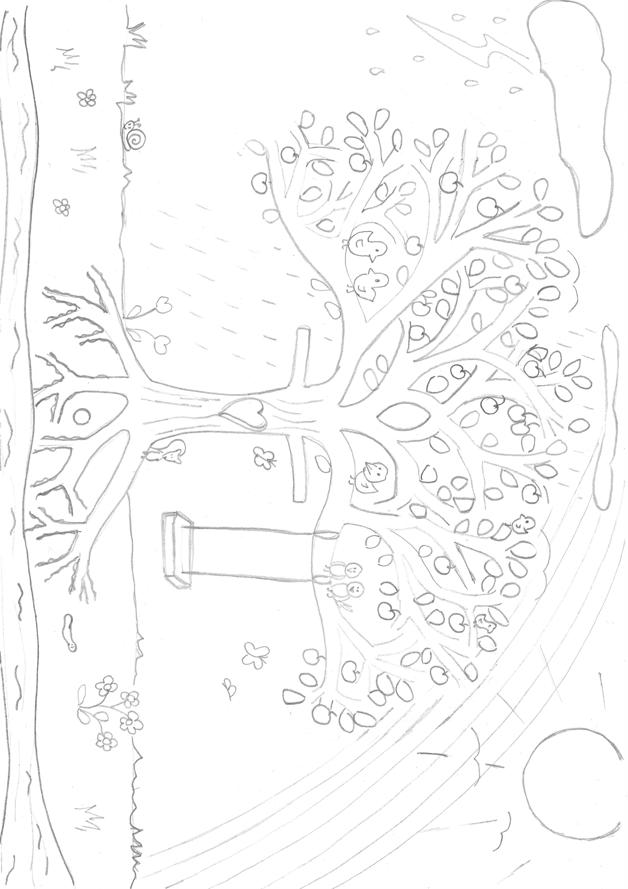
The roots go down into the rich soil and take all the nutrients to the tree, growing strong and providing support for the tree whatever weathers and circumstances come – we teach/learn in words and actions our school values which help us be live the best way whatever happens in life.
The fruit that grows – our values of love, honesty, forgiveness, and compassion as we flourish together and individually.
The rainbow needs the rain and sun together – the beauty of life and the good things that can come from living and being loved through the hard times too.
The sun, giving light and warmth, always there even though at times it can’t be seen (cloudy days, nights) – God’s love bringing life, beauty, growth, comfort, joy whether we are fully aware of it or not.
Birds come and perch in the branches, the tree creates shade/shelter for the animals and creatures – giving to the community and the world by being who we are.
The seed growing to be a tree – each of us individually and as a community – growing in our Spirituality in our lives. A tree sheds its leaves and nourishes the soil that feeds others and itself – we enrich each other and ourselves – teachers, children, parents, governors.
Stormy/rainy weather – challenging times

The tree trunk in the shape of a cross with the heart shaped hole – at the centre of our Spirituality - the Christian belief of Jesus’ death for us demonstrating true love, enabling us to know God.
The healthy rich soil – the wholesome environment in which our values of love, honesty, compassion, and forgiveness allow us all to flourish.
The river of life, moving and changing – the passing of time and changing of circumstances.
The leaves, healthy when the tree is healthy, receiving sunlight themselves to make food – proactive and equipped – making our own good choices.

The swing, fun! – the joy of life and the joy we can bring to others, the chance to be who we are made to be.

Spirituality at Freeland C of E Primary School

