**EYFS Curriculum at Freeland Primary School - All about me Autumn Term one**

Maths

Following the NCTEM progression charts, alongside the White Rose resources, children will work towards learning about the following skills:

* **Shape and space (developing special awareness and special vocabulary)**

Shape and Space NCETM

<https://www.ncetm.org.uk/media/4uljtty3/typical-progression-shape-and-space.pdf>

White Rose – Light and Dark and Just Like Me

<https://wrm-13b48.kxcdn.com/wp-content/uploads/2021/02/Phase-1-Just-like-me.pdf>  
<https://wrm-13b48.kxcdn.com/wp-content/uploads/2020/11/Phase-3-Light-and-Dark.pdf>

* **Developing early number sense (numbers to 5)**  
  Cardinality and counting (6 stages from cardinality and counting NCETM)  
  <https://www.ncetm.org.uk/media/zpujdwv4/typical-progression-cardinality-and-counting.pdf>  
  White Rose – Alive in 5!  
  <https://wrm-13b48.kxcdn.com/wp-content/uploads/2020/11/Phase-2-Its-Me-123.pdf>

<https://wrm-13b48.kxcdn.com/wp-content/uploads/2021/02/Phase-4-Alive-in-5.pdf>

Select, rotate and manipulate shapes in order to develop spatial reasoning skills in order to develop the following skills:

* Developing spatial awareness: experiencing different viewpoints
* Developing spatial vocabulary.

Count objects, actions and sounds in order to develop the following skills:

* Counting: saying number words in sequence.
* Counting: tagging each object with one number word.
* Matches numeral and quantity correctly.
* Shows an interest in representing numbers.

Subitising in order to develop the following skills:

* Recognising small quantities without needing to count them all.

Link the number symbol (numeral) with its cardinal number value:

* Numeral meanings.

High Quality Texts

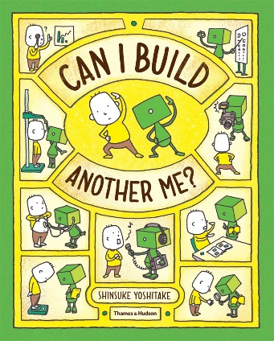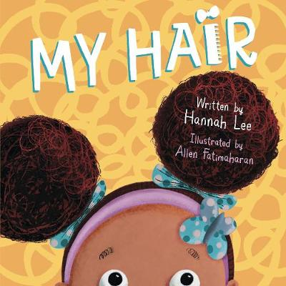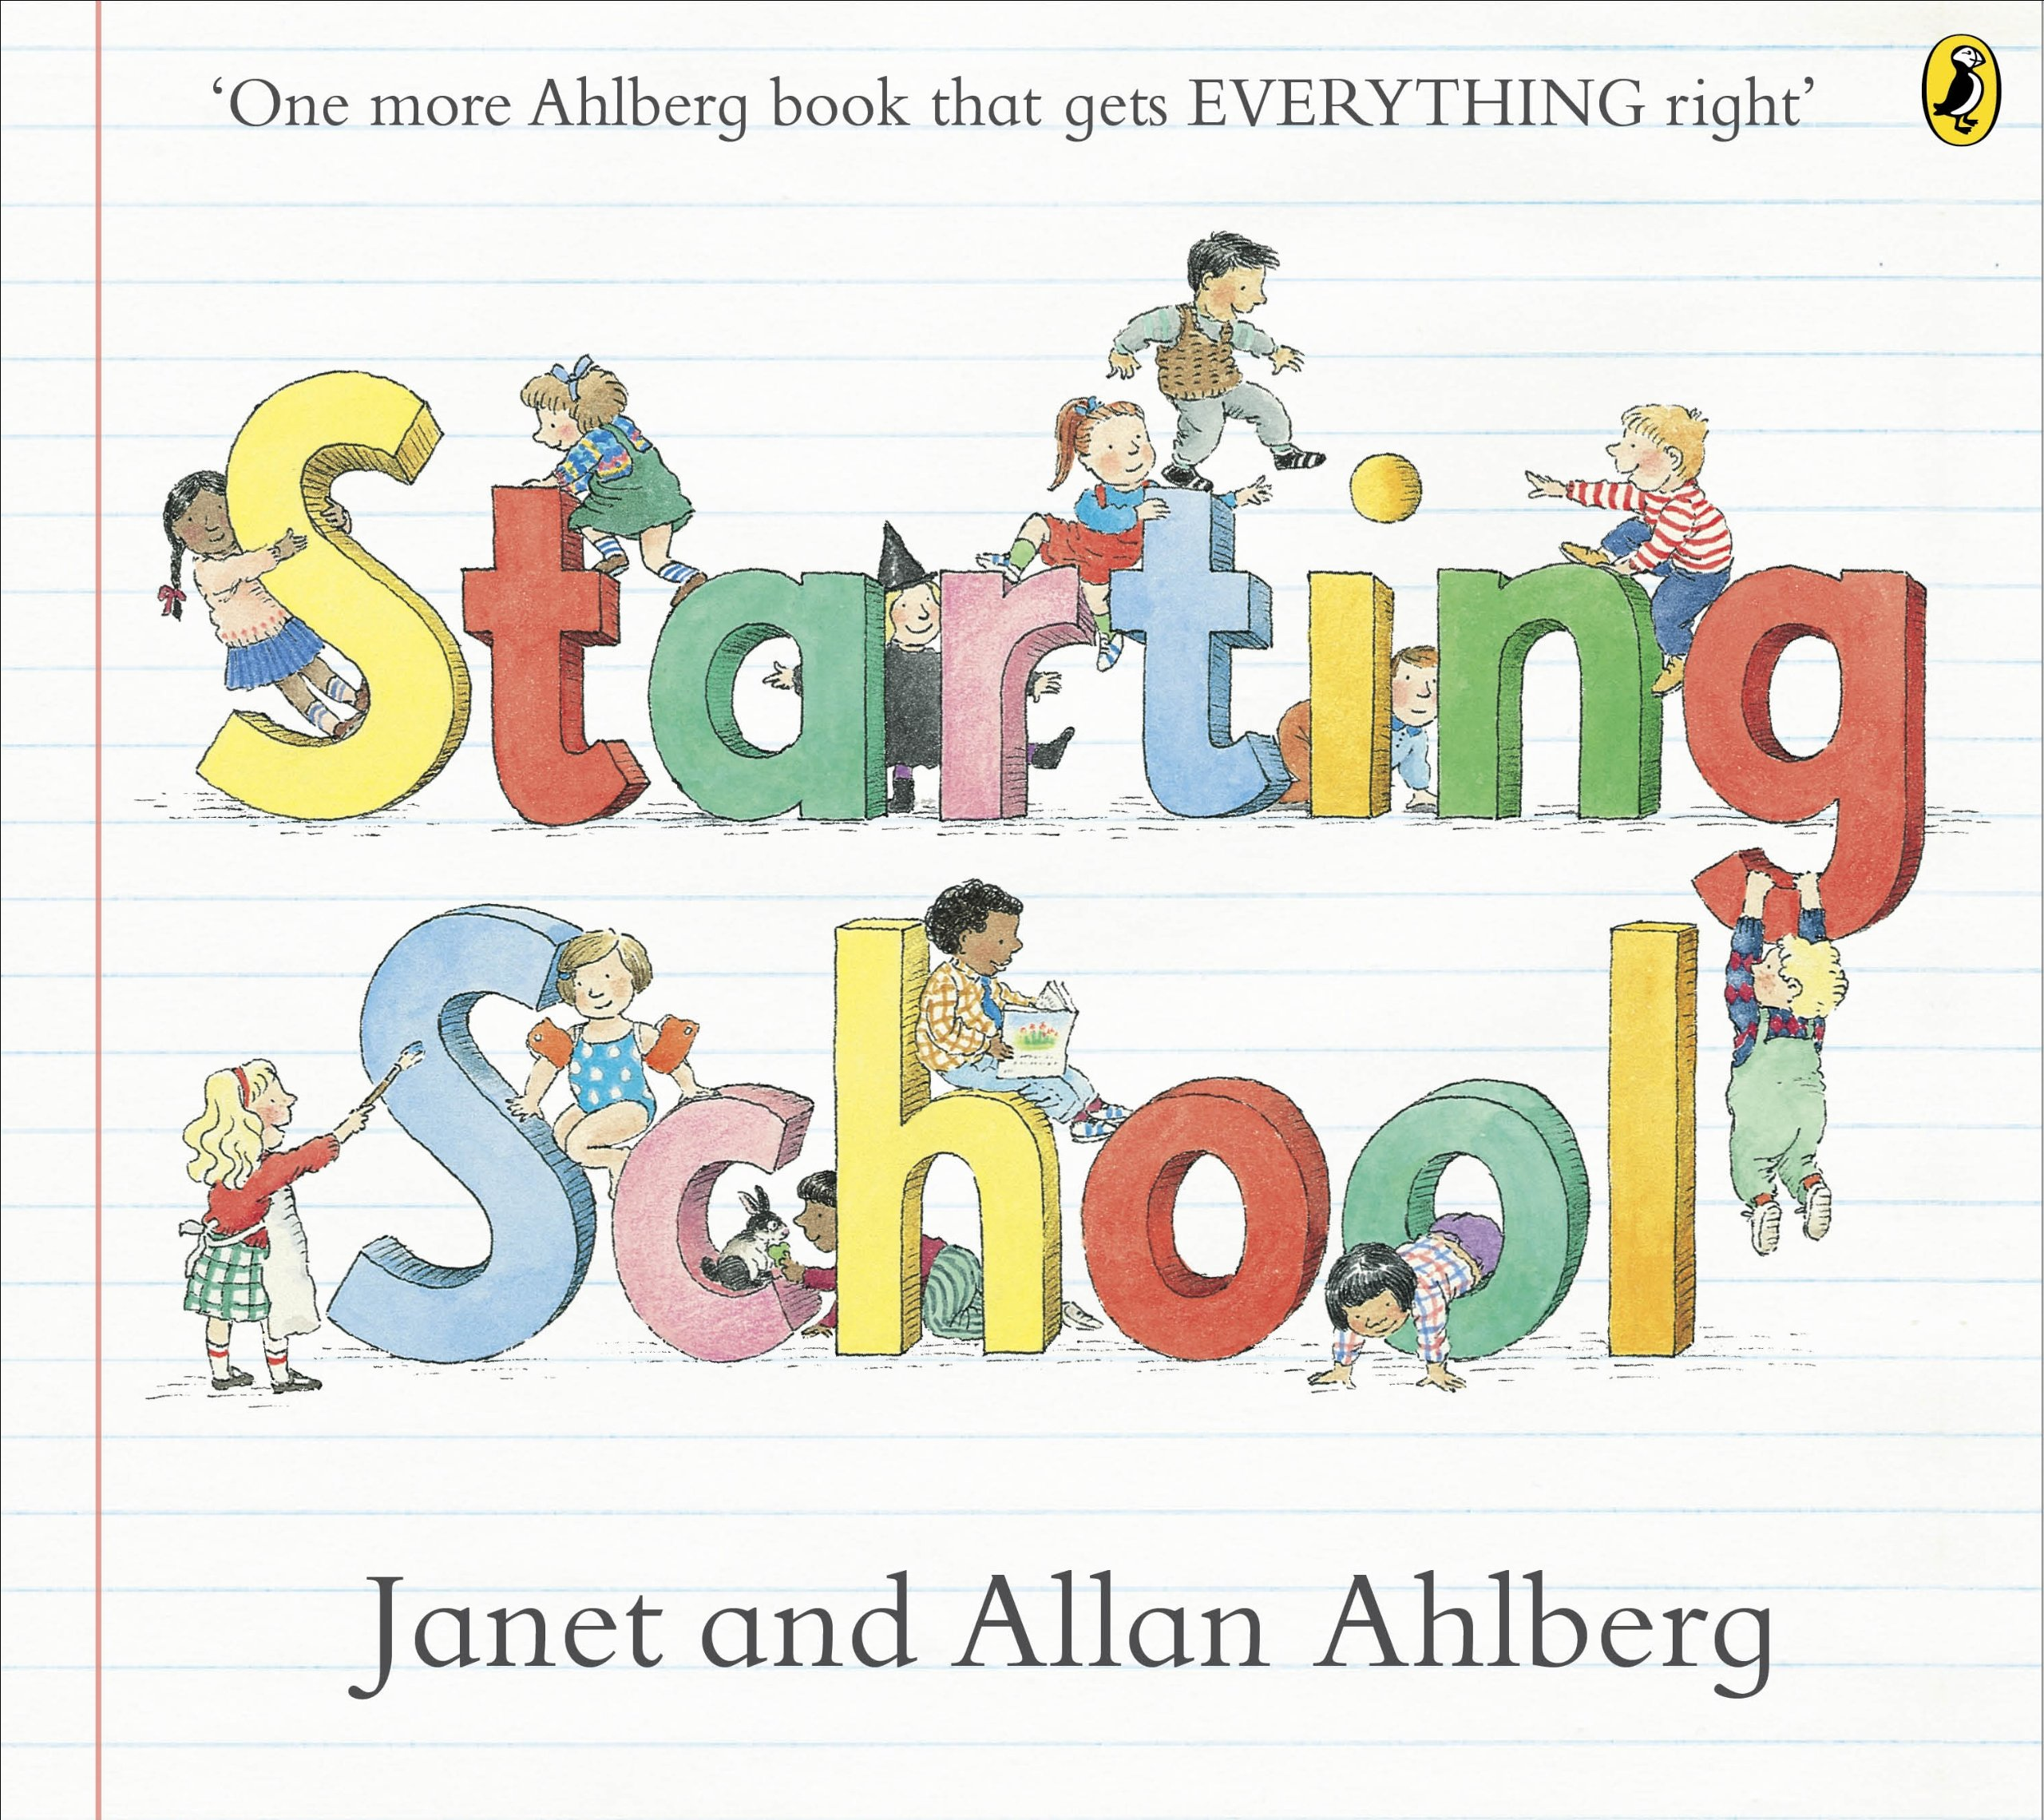

Experiences:

A School tour to get children familiar with their new environment and meet members of staff.

A trip around the local community, visiting the library, post office and the village shop.

Key vocabulary:

* You, me, family, culture, routine, household, hygiene, clean, listen, instruction, questions, answers, differences, village, town, family tree, traditions.

Personal social and emotional development

* Learn to separate well from our parent/carer
* Explore the school rules and values
* Make new friends and relationships with the adults in the classroom
* Circle times to encourage communicating with peers
* Building self- confidence by identifying positive points about ourselves.
* Developing confidence in the classroom when selecting resources and initiating play with others.

In order to develop the following skills:

* Become confident approaching new children and starting to build positive friendships.
* Initiates conversations, attends to and takes account of what others say.
* Can select and use activities and resources with help.
* Confident to speak to others about own needs, wants, interests and opinions.
* Can describe self in positive terms and see themselves as a valuable individual.
* Aware of own feelings and knows that some actions and words can hurt others’ feelings.
* Understands that own actions affect other people, for example, becomes upset or tries to comfort another child when they realise they have upset them.

Literacy

* Develop name writing skills and start to explore the names of family members
* Develop hearing and writing initial sounds/CVC words through writing captions, writing about past experiences, labelling objects and people.
* When exploring the local community, write labels for features of the environment: houses/shops.

In order to develop the following skills:

* Begin to write own name and other things such as labels, captions.
* Start to segment the sounds in simple words and blend them together to read and write CVC words.
* Start to form recognisable letters.

Expressive arts & design

* Role play opportunities that include acting out family traditions, school, shops, vets.
* Create family and self-portraits using different materials
* Explore traditional and pop music that reflect the children’s interests and other cultures.

In order to develop the following skills:

* Developing their own storyline in play.
* Create collaboratively and share ideas, resources, equipment and skills with other children in the class.
* Respond to a range of music, art and performance and practise responding appropriately to others.

Communication and Language

* Listen to a wide range of stories about families, differences and ourselves
* Develop listening and responding skills at circle time
* Use photos of family members to talk about them
* Practise language through skills during role play, negotiating activities etc
* Understand simple sentences and instructions
* Work on questions, what a question is and some examples of this

In order to develop the following skills:

* Understand how to listen carefully and why listening is important.
* Start to explore, learn and use new vocabulary throughout the day.
* Exploring how and why things happen through discussions and talk.
* Listens and responds to ideas expressed by others in conversation or discussion.
* Develop confidence when articulating ideas and thoughts in well-formed sentences.
* Introducing a storyline to play that reflects their own experiences.

Understanding the world

* Explori**ng** different types of families **a**nd understanding they can be different.
* Explore the local area and show simple landmarks on a map.
* Make family trees
* Look at other cultures and traditions.
* Look at the past and present in relation to ‘self’
* Identify ways in which people are different such as appearance, personality and likes/dislikes.
* Begin to look at our senses

In order to develop the following skills:

* Develop confidence talking about members of their family and community and reflect on past experiences and events in their life.
* Exploring their local area and describing key features such as shops, roads, buildings and showing this on a simple map.
* They know about similarities and differences between themselves and others and exploring different beliefs and celebrations.
* Understand that there are family members from the past and how their life may be different to their own now.

Physical development

* Explore routines at home that include hygiene and self- care, including oral health.
* Labelling body parts
* Developing pencil grip in a range of activities
* Create activities for children to explore fine motor skills
* Use the bikes in the garden to develop gross motor skills

In order to develop the following skills:

* Develop their small motor skills so that they can handle tools, objects, construction and malleable materials safely and with increasing control.
* Shows some understanding that good practices with regard to exercise, eating, sleeping and hygiene can contribute to good health, including *oral health*.
* Develop the overall body strength, coordination, balance and agility.