**EYFS Curriculum at Freeland Primary School –Off to Space: Spring Term two**

 Maths

Following the NCTEM progression charts, alongside the White Rose resources, children will work towards learning about the following skills:

* **Shape and Space**

Shape and Space (NCETM)

<https://www.ncetm.org.uk/classroom-resources/ey-shape-and-space/>

* **Cardinality and counting**

Counting (NCETM)

<https://www.ncetm.org.uk/classroom-resources/ey-cardinality-and-counting/>  
White Rose – Growing 6,7, 8 and Building 9 and 10

<https://wrm-13b48.kxcdn.com/wp-content/uploads/2021/02/Phase-5-growing-678.pdf>

<https://wrm-13b48.kxcdn.com/wp-content/uploads/2021/02/Phase-6-Building-9-and-10.pdf>

* **Comparison**

Comparison (NCETM)

<https://www.ncetm.org.uk/classroom-resources/ey-comparison/>

Select, rotate and manipulate shapes in order to develop spatial reasoning skills to develop the following skills:

* Shape awareness: developing shape awareness through construction.
* Identifying similarities between shapes.

Compose and decompose shapes so that children recognise a shape can have other shapes within it, just as numbers can to develop the following skills:

* Showing awareness of properties of shape.
* Describing properties of shape.
* Developing an awareness of relationships between shapes.

Consolidation of term one and two aspects of cardinality and counting.

Compare numbers to develop the following skills:

* Identifying groups with the same number of things

Understand the ‘one more than/one less than’ relationship between consecutive numbers to develop the following skills:

* More than/less than
* Knowing the ‘one more than/one less than’ relationship between counting numbers

Communication and Language

* Watching age appropriate documentaries about space and the solar system
* Question and answer session with ‘an astronaut’
* Describing planets to a friend who has to guess the name correctly
* Exploring what an astronaut might say to a friend over email.

In order to develop these skills:

* Listen to and talk about non-fiction to develop a deep familiarity with new knowledge and vocabulary.
* Use new vocabulary in different contexts
* Articulate their ideas and thoughts in well- formed sentences
* Introducing a storyline to play which recreates their experiences.

Physical development

* Cutting out different shapes to resemble a rocket and create rocket pictures
* Creating UFOs from paper plates and other materials for decoration
* Through dance, act out a space mission at different stages, the take-off, the journey, the landing and exploring an unknown planet
* Continue to explore overall health; hygiene, diet, exercise, screen time and sleep.

In order to develop the following skills –

* Develop motor skills so the children can handle tools responsibly and safely
* Develop the overall body strength, balance, co-ordination and agility.
* Continue to develop the foundations of a handwriting style which is accurate and efficient.

Experiences:

Science Oxford workshop

A visit from planetarium

Question and answer session with an ‘astronaut’

Personal social and emotional development

* Continue to look at the JIGSAW scheme of work focussed on looking after ourselves and others
* Work with other children during topic activities such as rocket making/designing/role play
* Explore emotions through the thoughts of an astronaut around the themes of loneliness, facing new challenges and being brave.

In order to develop the following skills:

* Explains own knowledge and understanding and asks appropriate questions of others
* Confident to speak to others about own needs, wants interests and opinions.
* Children gain confidence to communicate their opinions.
* Considers the thoughts and feelings of others whilst moderating their own feelings socially and emotionally.

Literacy

* Writing a letter to an astronaut about his/her experiences in space
* Labelling and writing captions for each of the planets
* Researching about planets and space using the internet
* Exploring high quality texts about space and retelling some of the stories learned
* Write captions/sentences with adjectives to describe an alien

In order to develop the following skills:

* Read and write a few common exception words based on the school’s phonics programme
* Read simple phrases and sentences made up of letter- sound correspondence
* Re read what they have written to ensure it makes sense.

Expressive arts & design

* Acting out scenes from space in a space station role play
* Through dance, acting out a space mission at different stages; the take-off, the journey, the landing
* Creating pictures of planets using marble paint
* Create rockets using junk modelling

In order to develop the following skills-

* Develop storylines in pretend play that reflect their own knowledge and understanding
* Explore and engage in music making and dance, performing solo or in small groups.

High Quality Texts

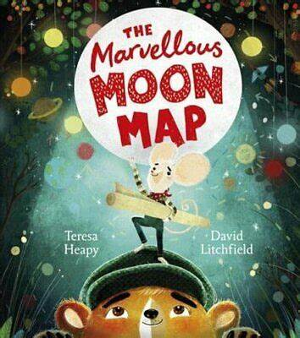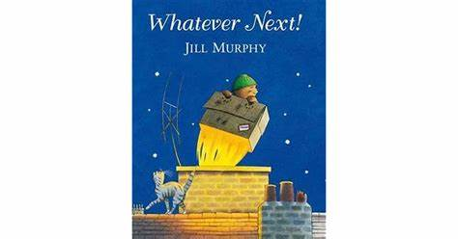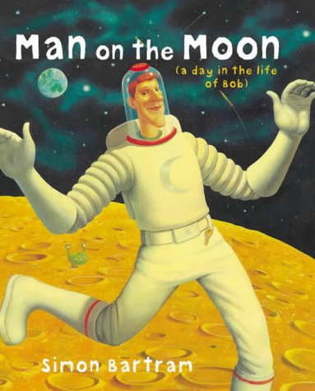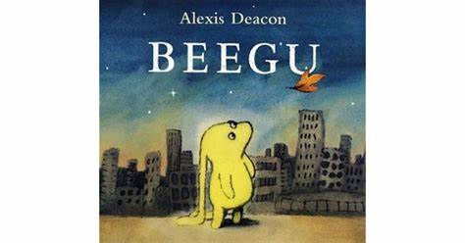

Key vocabulary:

* Space, rocket, alien, planets, galaxy, stars, solar system, moon, astronaut, oxygen, space suit, crater.

Understanding the world

* Explore the different planets through research and exploring models
* Conduct an experiment around air: launching rockets
* Create a space mobile as a class that includes 3D planets
* Exploring the globe and looking at different continents and countries
* Join in with discussions about climate change and global warming and the impact we can have on the planet

In order to develop the following skills:

* Talk about the features of their own environment and how it differs from others immediate environment
* Explores the natural world around them, developing an understanding of space.
* Understand climate change and global warming and the impact it has on our lives.