**EYFS Curriculum at Freeland Primary School –Once upon a Time: Summer Term two**

Literacy

* Ordering and sequencing fairy tales stories using story maps
* Acting out famous fairy tales in role play
* Writing captions for images of famous fairy talks to develop sentence writing
* Explores rhythmic pattern in key fairy tales
* Writing instructions on how to be a good or bad wolf, how to make a gingerbread house.

In order to develop the following skills:

* Continue a rhyming string
* Shows an interest in illustration and print in books and print in the environment
* Enjoys an increasing range of books and use these to build confidence with word reading, fluency and understanding.
* Writes short sentences and captions with known- letter correspondence using capital letters and full stops

Maths:

Following the NCTEM progression charts, alongside the White Rose resources, children will work towards learning about the following skills:

* **Pattern**

Pattern (NCETM)

<https://www.ncetm.org.uk/classroom-resources/ey-pattern/>

White Rose – Pattern – On the Move!

<https://wrm-13b48.kxcdn.com/wp-content/uploads/2021/03/Reception-Scheme-Phase-9-Summer-2021.pdf>

<https://wrm-13b48.kxcdn.com/wp-content/uploads/2021/03/Reception-Scheme-Phase-10-Summer-2021.pdf>

* **Cardinality and counting**  
  Conservation: knowing that the number does not change if things are re-arranged (NCETM)

<https://www.ncetm.org.uk/classroom-resources/ey-cardinality-and-counting/>  
White Rose – First, Then, Now

<https://wrm-13b48.kxcdn.com/wp-content/uploads/2021/02/Phase-7-To-20-and-Beyond.pdf>

<https://wrm-13b48.kxcdn.com/wp-content/uploads/2021/02/Phase-8.pdf>

* Comparison including measurement
  + More than and less than
  + Recognise lengths, weights and capacities that are the same.

Continue, copy and create repeating patterns. In order to develop the following skills:

* Continuing an AB pattern
* Copying and AB pattern
* Make your own AB pattern
* Spotting an error in an AB patter
* Identifying the unit of repeat

Consolidation of term one aspects of cardinality and counting.

Compare length, weight and capacity in order to develop the following skills:

* Recognising attributes
* Comparing amounts of continuous quantities (more than and less than)

Personal social and emotional development

* Opportunities for group work to develop children’s confidence in communicating with others and creating their own fairy tale
* Role play opportunities for children to respond to each other’s play
* Use fairy tales to learn lessons about life such as telling the truth or being a good/bad friend.

In order to develop the following skills:

* Can play in a group, extending and elaborating plat ideas and build relationships with other children
* Think about the perspective of others and how to treat others with respect
* Value themselves as a respected individual who is willing to contribute ideas.

Expressive arts & design

* Performing traditional song and tales with actions
* Group work when acting out fairy tales with props
* Design their own front covers for traditional fairy tales
* Explore existing artwork around traditional tales and recreate in groups.

In order to develop the following skills-

* Explore and use a variety of artistic effects to express their feelings and ideas.
* Explore existing artwork and begin to explore replicating styles and designs.
* Explore and engage in music making and dance, performing solo or in groups.

Communication and Language

* Developing the language of storytelling through role play activities
* Opportunities to listen to a range of storytelling through role play activities.
* Develop confidence when retelling stories that include actions and key phrases
* Join in retelling stories as a class on a regular basis.

In order to develop these skills:

* Engage in story times and listen with increasing attention and recall.
* Joins in with repeated refrains and anticipates key events and phrases in rhymes and stories.
* Retell the story including exact repetition and own words once familiar in a text.
* Use language to imagine and recreate roles and experiences in play situations that reflect an understanding of key fairy tale texts.

Physical development

* Developing an effective pencil grip when writing captions and sentences based on fairy tales
* Using a variety of tools such as paintbrushes, scissors, play dough cutters to create pictures and models of fairy tales.
* Incorporate different actions and ways of movement when acting out fairy tales.

In order to develop the following skills –

* Moves freely with pleasure and confidence in a range of situations.
* Holds pencil near point between first two fingers and thumb in order to develop accurate handwriting style.

Experiences

Visit from an actor/fairy tale character

Visit from a child’s author

Story museum- Oxford

High Quality Texts

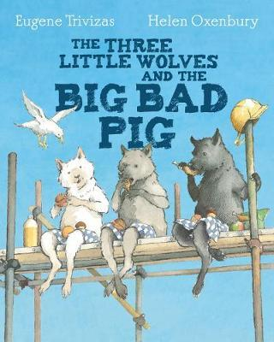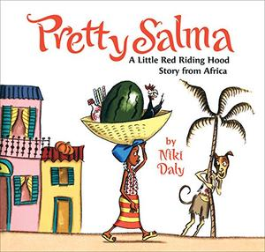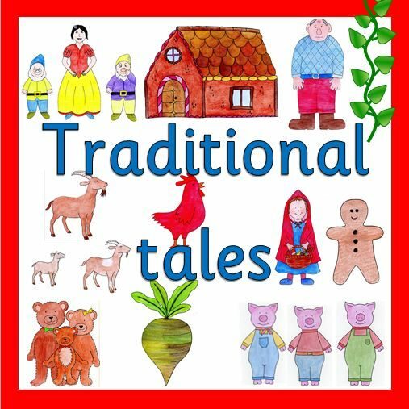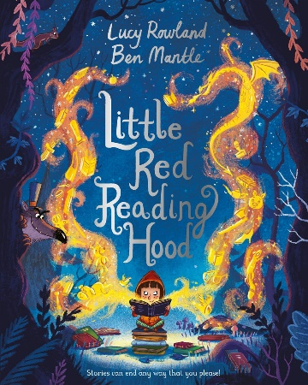

Key vocabulary:

* Story, setting, fairy tale, traditional tale, hero, castle, giant, princess, villain, woods, story map, plot, character

Understanding the world

* Making observations of landscapes and fairy tale settings
* Explore how seasons change linked to key texts and picture books
* Explore how fairy tales have changed over time and compare new stories to traditional tales
* Develop home skills liked to cooking. E.G. making gingerbread men
* Investigations linked to fairy tales including 3 little pigs

In order to develop the following skills:

* Develop an understanding of growth, decay and change over time
* Compare and contrast characters from stories including figures from the past.
* Develop investigate skills through making predictions and testing out ideas.
* Describe settings and their key features such as trees, hills and rivers.