Diary

**English** **Key Texts:** *The Queens’ Hat, Old bear Stories. Dogger, Up and Up and Fireside Stories* (by Shirley Hughes).

**Text Types Narrative:** Traditional Tales with predictable, patterned texts (The Enormous Turnip)

**Non-Fiction:** Labels, captions and lists- Our class Toy Museum. **Instructions**- making a sandwich/cupcake for a Toys’ Christmas tea party **Invitation writing-** an invitation to a Toys tea party

**Poetry:** Poems on a theme: Toy riddles and autumn poems

**Maths**

Number: Place Value (within 10)

Number: Addition and Subtraction (within 10)

Geometry: Shape

Geometry: Position and Direction

Number: Place Value (within 20)

Consolidation

**Science**

Weather and Seasonal Changes

Materials

**ICT**

Programming- Bee-bots

Creating- William Morris designs

E-Safety

**‘Best of British’**

Autumn Term

**PE**

Real PE themes: Coordination, Static balance, Dynamic balance to Agility.

Ignite Sports

**Year 1 OWLS**

**OWLS**

**Art/DT**

Sketching/line drawings- real leaves and those used in William Morris designs, toys and owls.

Design and create a toy

Printing with leaves

Painting – Renoir *Les Parapluies* (Rainy Day)

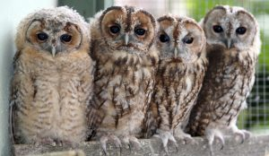

**Geography/History** United Kingdom including the Royal Family Human & Physical Geography- Seasonal and daily weather patterns in the UK Changes within living memory –Toys from the past Finding out about real artists- William Morris.

**Music**

Charanga Music World –

Year 1 Scheme of Work.

**PSHCE**

Being me in my World

Celebrating differences

**RE- Christianity**

The Creation Story

The Christmas Story